Technical Datasheet Smart Weather Monitoring System
System Overview:
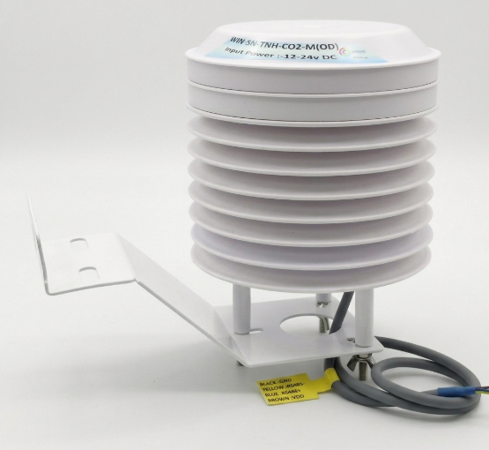
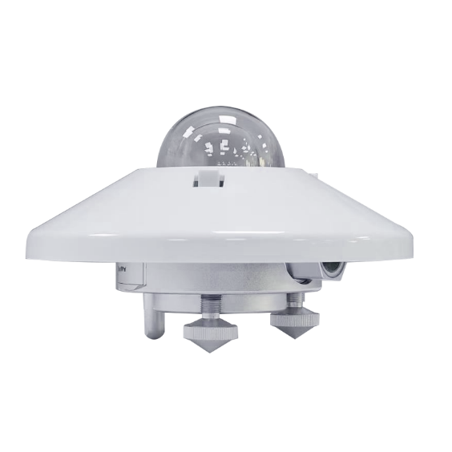
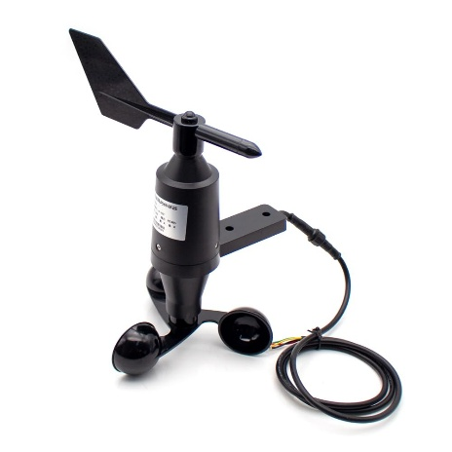
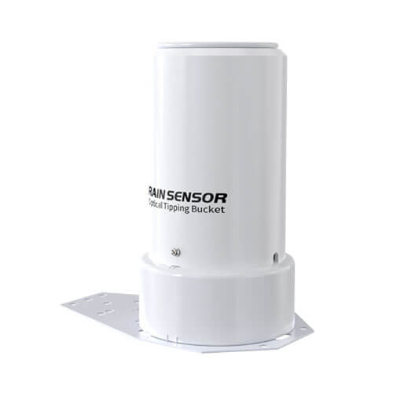
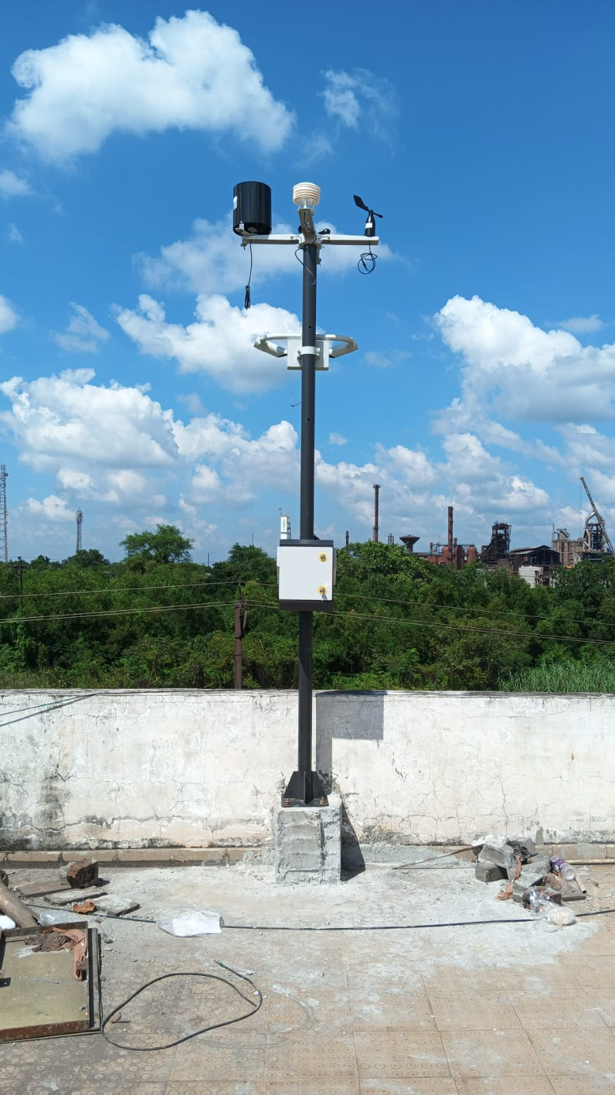
The Smart Weather Station is a comprehensive, standalone meteorological and environmental monitoring solution designed for outdoor applications and industrial facilities. It combines highly accurate, distributed sensing with real-time local visualization, robust data logging, and advanced IoT connectivity to continuously monitor weather patterns, air quality, and environmental health.

System Architecture & Components:
The complete kit operates on a robust, hardwired Modbus RS485 communication network and consists of the following hardware.
- Master Display & Gateway Unit: The central hub of the system. It features an integrated touch display for intuitive, real-time visualization and acts as a Modbus Master device to continuously pull data from the connected sensor suite. Functioning as a powerful IoT gateway, it is equipped with Wi-Fi, 4G cellular connectivity, and GPS, enabling reliable upstream communication to cloud platforms or Building Management Systems (BMS). It also features an integrated SD card module for secure local data storage and historical logging.
- Meteorological & Air Quality Sensor Suite: The gateway supports a comprehensive array of precision outdoor sensors, all communicating seamlessly over the Modbus network. The supported measurement parameters include:
  - Solar Irradiance
  - Temperature & Humidity (TnH) with Gas Detection (CO/ CO2/ NO2/ SO2)
  - Wind Speed & Direction
  - Rain Detection
Hardware Protection & Core Features:
The system is housed in rugged, industrial-grade enclosures designed for reliable operation in harsh, demanding outdoor environments. The Master Gateway features a high-visibility integrated touch display with intuitive data visualization. By utilizing secure and highly stable wired Modbus communication, the system ensures uninterrupted, interference-free data acquisition from the external weather sensors. The combination of advanced remote telemetry (4G/Wi-Fi/GPS) and localized SD card data logging guarantees that critical meteorological data is continuously captured and securely transmitted, regardless of the deployment location.
Sensor Specifications:
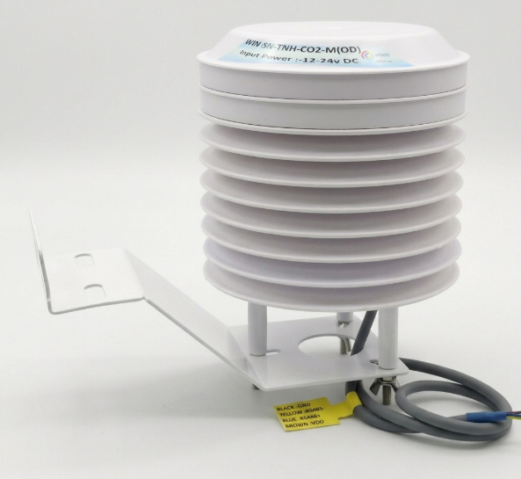
The WIN-SN-TNH-CO2-M (OD) is a rugged, industrial-grade outdoor environmental sensor engineered for precision and reliability.
- Sensing: Temperature, Humidity, and CO2
- Output: RS485 (Modbus RTU)
- Power: 12-24V DC
- Design: Weather-resistant, low-maintenance radiation shield

The BGT-TBQ(L) Total Radiation Sensor is a professional-grade pyranometer engineered to measure hemispherical solar radiation with exceptional accuracy and a long service life. It is an ideal, low-maintenance solution for solar power monitoring, building physics, and outdoor meteorological applications.

- Measurement: Total Solar Radiation (W/m²)
- Spectral Range: 300–1100nm
- Output Options: RS485 (Modbus), 4-20mA, 0-5V
- Key Features: High sensitivity, low power consumption, and a maintenance-free design
- Hardware: Double glass cover construction for high-precision, low-error thermal measurement

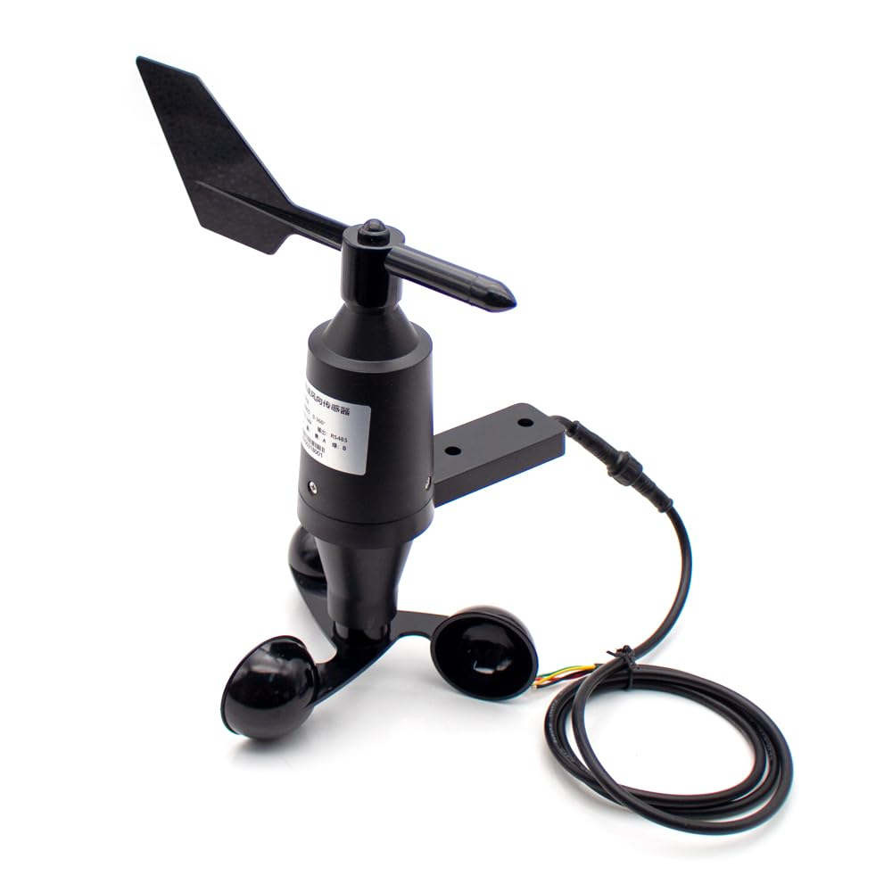
The RD-WSDASA-01 is a rugged, two-in-one outdoor meteorological sensor engineered for precise wind speed and direction measurement. Constructed from UV-resistant ASA plastic, it features self-lubricating bearings and anti-electromagnetic interference for highly accurate, low-maintenance performance.
- Sensing: Wind Speed (0~60 m/s) and Wind Direction (0-359°)
- Output: RS485 (Modbus)
- Power: 12-24V DC
- Design: IP65 weather-resistant, ASA anti-ultraviolet engineering plastic


The Small Optical Tipping Bucket Rainfall Sensor is a highly precise, compact device engineered for reliable outdoor precipitation and ambient light measurement. Utilizing advanced optical pulse principles, it delivers high accuracy and ultra-low power consumption in a space-saving footprint, making it ideal for distributed weather stations and environmental monitoring networks.
- Sensing Parameters: Rainfall (0.1mm resolution) and Ambient Light (0–200,000 Lux)
- Accuracy: Rainfall ±4%, Light ±7%
- Max Rainfall Rate: 24mm/min
- Output: RS485
- Power: 9~30V DC (Ultra-low consumption <0.24W)
- Hardware Design: Compact 6cm sensing diameter, robust for -40°C to 80°C operating environments
Flexible System Configuration:
The system is designed for both robust local control and seamless remote management. Users can fully customize environmental alarm thresholds (such as toxic gas concentration limits or extreme weather alerts), SD card data logging intervals, and sensor parameters directly through Master Gateway's local touch display. Alternatively, these parameters can be configured remotely via the integrated Wi-Fi and 4G interfaces. This flexible configuration enables the system to be rapidly optimized for different geographical locations and specialized industrial requirements.

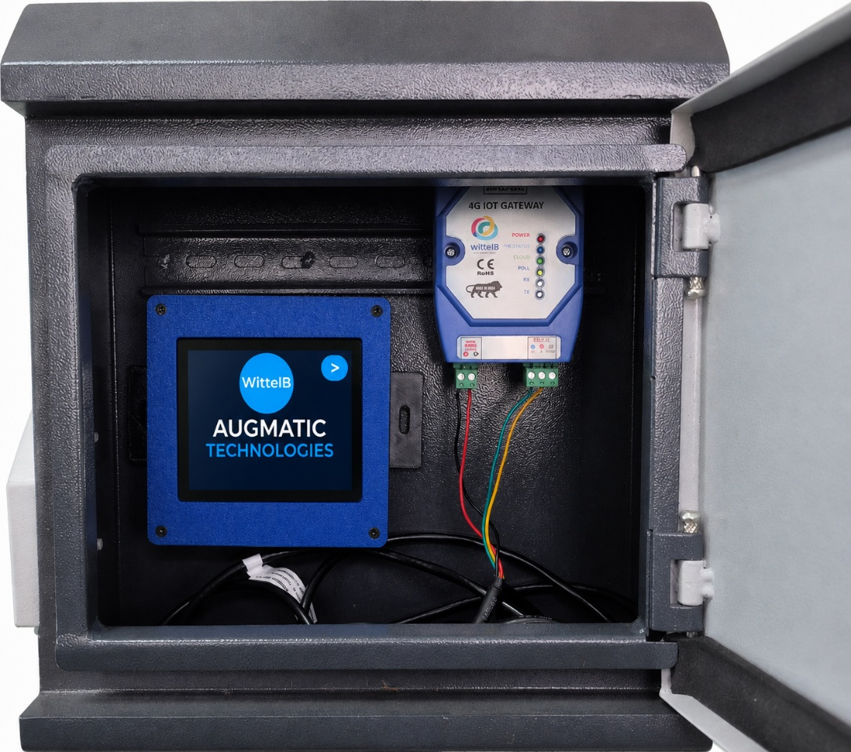
Advanced Connectivity: Wi-Fi, 4G Telemetry & GPS:

- Local Wireless Configuration: Unlocking advanced flexibility for field engineers and maintenance personnel, the Master Gateway Unit is equipped with an integrated Wi-Fi module to simplify outdoor deployment. By connecting wirelessly via a smartphone, tablet, or laptop, operators can quickly access the system's configuration interface without opening the enclosure or requiring physical serial cables. This allows for effortless sensor calibration, alarm threshold setup, network configuration, and system diagnostics directly from the installation site.
- 4G IoT Telemetry & GPS Tracking: 4G cellular connectivity transforms the Smart Weather Station into a fully autonomous IoT solution capable of powerful remote telemetry—even in isolated locations without local networks. Utilizing lightweight MQTT protocols, the Master Gateway securely publishes real-time meteorological data (Solar Irradiance, Wind Speed/Direction, Rainfall, TnH) and precise air quality metrics (CO, CO₂, NO₂, SO₂) to cloud-based dashboards. Furthermore, the integrated GPS module provides precise geolocation tagging for all transmitted data, ensuring accurate spatial mapping for distributed weather monitoring networks.

Contact us: -
Augmatic Technologies Pvt. Ltd.,
Plot no 6, Shah Industrial Estate II,
Kotambi,
Vadodara – 391510.
Email – Sales@wittelb.com
Support: support@wittelb.raiseaticket.com / +91 94038 92805

